<html>

<style>

#box

{

width:400px;

height:250px;

border:2px solid green;

background-color:red;

position:relative;

margin: 40px;

}

#box2

{

position:absolute;

padding-top:25px;

padding-left:20px;

font-size: 15px;

}

#box3

{

position:absolute;

padding-top:15px;

padding-left:20px;

font-size: 10px;

}

</style>

<script>

function isPositive()

{

var num =document.getElementById("no_input").value;

var result;

if (num > 0)

{

result = true;

document.getElementById("demo").innerHTML = "The number is positive";

} else if (num < 0) {

result = false;

document.getElementById("demo").innerHTML = "The number is negative";

}

}

</script>

<body>

<div id="box">

<div id="box2">

<h1>Ckeck the given number is positive or negative</h1>

<label>Enter the number:</label><input type="text" id="no_input" >

<button onclick="isPositive()" >Check</button>

<div class="box3">

<p id="demo"></p>

</div>

</div>

</div>

</body>

</html>

Output

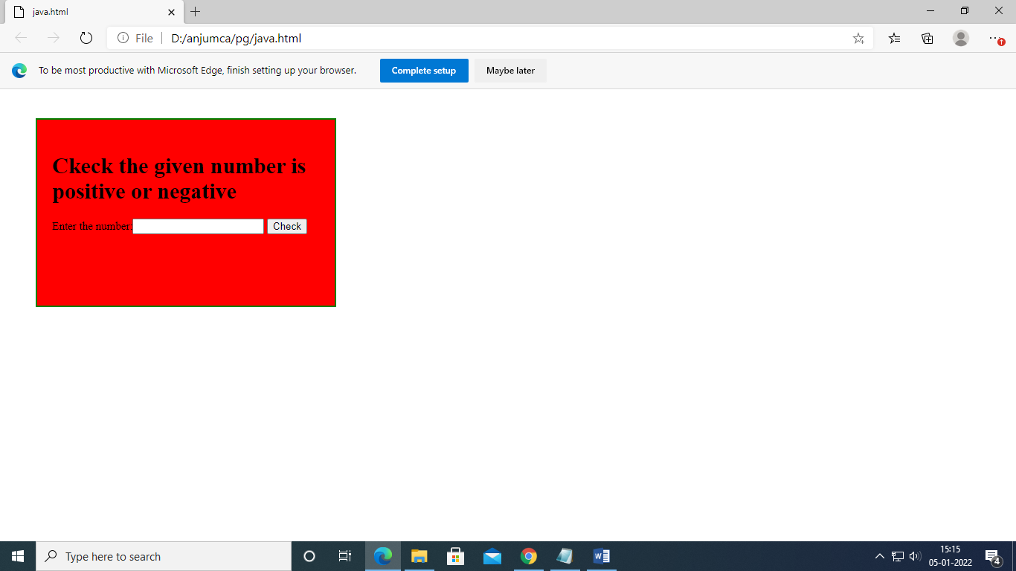

<html>

    <style>

        #box{

            width:370px;

            height:350px;

            border:2px solid red;

            background-color:#b4f00e;

            position:relative;

            margin:50px 100px;

        }

    </style>

    <script>

        function isPositive() {

        var num =document.getElementById("no_input").value;

        var result;

        if(num>0)

        {

            if (num%3==0&&num%7==0) {

                document.getElementById("demo").innerHTML = num+" "+"is a multiple of 3 and 7"

            }

            else if(num%3==0){

                document.getElementById("demo").innerHTML = num+" "+"is a multiple of 3 not a  multiple of 7"

            }

            else if(num%7==0){

                document.getElementById("demo").innerHTML = num+" "+"is a multiple of 7 not a  multiple of 3";

            }

            else

            {

                document.getElementById("demo").innerHTML = num+" "+"is not a multiple of 7 and not a  multiple of 3" ;

            }

        }

        }

    </script>

    <body>

        <div id="box">

            <h1>Check if a given positive number is a multiple of 3 or a multiple of 7</h1>

            <label>Enter the number:</label><input type="text" id="no_input" >

            <button onclick="isPositive()" >Check</button>

            <p id="demo"></p>

        </div>

    </body>

</html>

Output

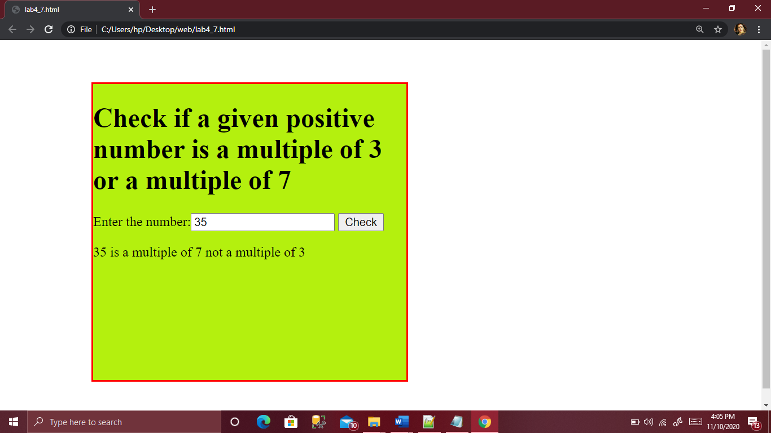

RESULT

<html>

<head>

<style>

.box

{

    margin:100px 500px;

    width:400px;

    height:260px;

    border:2px solid red;

    position:relative;

    border:2px solid white;

     background-color:#33FFBD;

}

.box1

{

     position:absolute;

     padding:50px 10px;

 }

input,button

{

     height:30px;

}

</style>

</head>

<body>

<div class="box">

<div class="box1">

<table>

 <tr>

<td>Enter first number:</td>

  <td><input type="text" id="num1" required style="border:0px ;border-radius:5px"></td>

 </tr>

<tr>

<td>Enter second number:</td>

<td><input type="text" id="num2" required style="border:0px ;border-radius:5px"></td>

</tr>

<tr>

<td>Enter third number:</td>

<td><input type="text" id="num3" required style="border:0px ;border-radius:5px"></td>

 </tr>

</table>

<input type="submit" value="Click here" onclick="fun();"  style ="background-color:black;color: white;border:0px ;border-radius:5px">

<h2></h2>

</div>

</div>

</body>

<script>

function fun()

{

        var num1=document.getElementById("num1").value;

        var num2=document.getElementById("num2").value;

        var num3=document.getElementById("num3").value;

   //checking whether the input value is a number or not

        var v1=isNaN(num1);

        var v2=isNaN(num2);

        var v3=isNaN(num3);

        var largest;

        if(num1&&num2&&num3&&!v1&&!v2&&!v3)

        {

            console.log(num1);

            console.log(num2);

            console.log(num3);

            if(num1 >= num2 && num1 >= num3)

           {

                largest = num1;

            }

            else if (num2 >= num1 && num2 >= num3)

          {

                largest = num2;

            }

            else

          {

                largest = num3;

            }

                var n=document.querySelector("h2");

                n.innerHTML="Largest"+" "+largest;

            }

        else

         alert("Please enter a number");

      }

    </script>

 </html>

Output

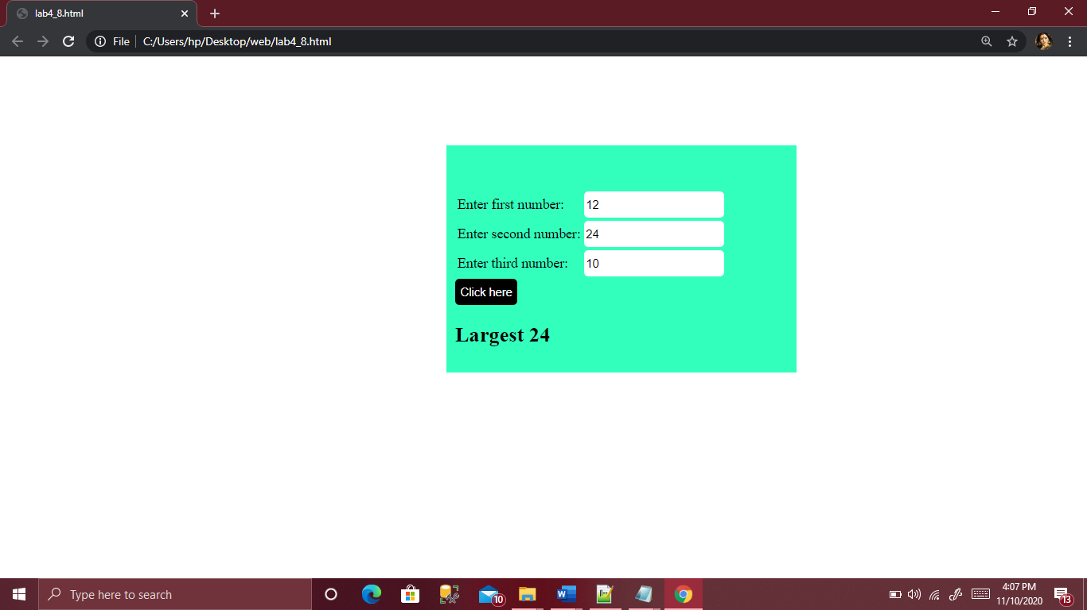

RTESULT

<html>

<head>

  <script>

    function string() {

       var x =document.getElementById("input").value;

      var y=x.slice(0,2);

       var val=(y==="Py"||y==="py"||y==="PY")? x:"Py"+x;

       var k =document.getElementById("demo");

       k.innerHTML="New String is:"+" "+val;

    }

</script>

  <style>

    #box{

         width:400px;

         height:200px;

         border:3px solid black;

         background-image: linear-gradient(red, yellow);

    }

    h1{

      text-align: center;

    }

  </style>

</head>

<body>

<div id="box">

<h1>Py finder</h1>

  <label for="input">Enter the word! </label><input type="text" id="input">

  <button onclick="string()">click me!</button>

  <p id="demo"></p>

</div>

</body>

</html>

OUTPUT

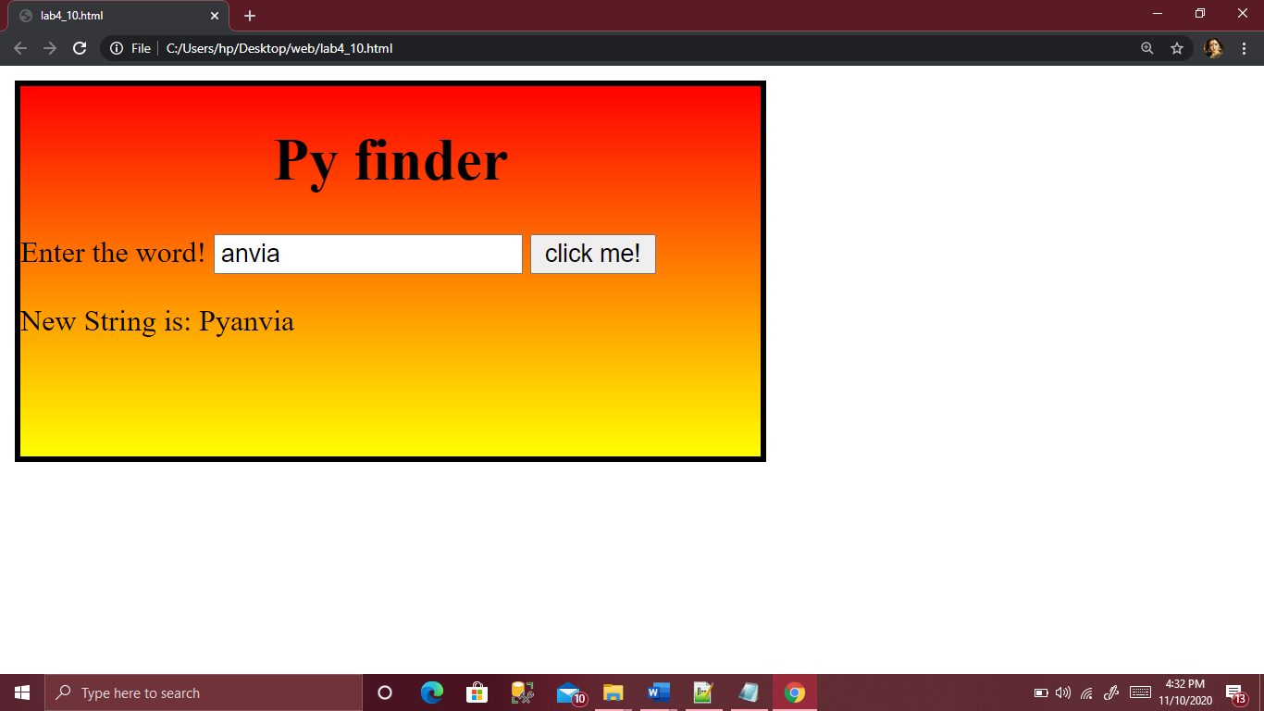

RESULT

<html>

<script>

 function changeBodyBg(color){

        document.body.style.background = color;}

          </script>

     </head>

     <body>

           <button type="button" onclick="changeBodyBg('yellow');">Yellow</button>

          <button type="button" onclick="changeBodyBg('lime');">Lime</button>

          <button type="button" onclick="changeBodyBg('orange');">Orange</button>

     </body>

</html>

OUTPUT

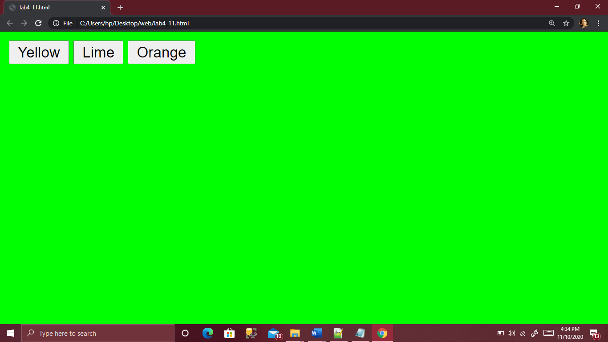

RESULT